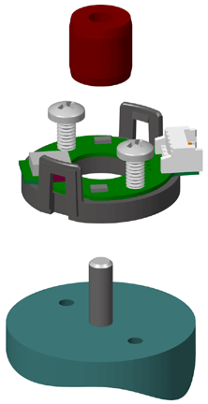**1. Base Mounting**

Place base onto shaft. Secure base to mounting surface using two screws.

**2. Spacer Installation**

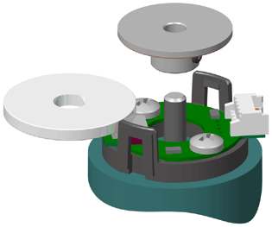Place spacer tool on optic module as shown below.

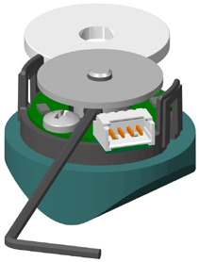**3. Codewheel Installation**

Slip codewheel onto shaft until it bottoms out against spacer tool. Spacer tool provides an air gap of 0.07" 0.03". Tighten set screw with either the hex wrench / hex driver while pressing down on codewheel.

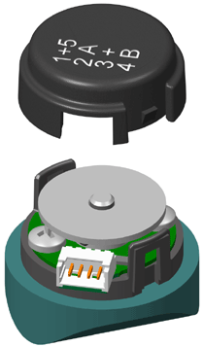**4. Cover Installation**

Place housing (cover) on. With thumb and finger, squeeze ears together to insure that cover fully latches.